# ***Challenge Name :- C00m3nts***

**Description:** In a hidden corner of the web's abode,Lies a challenge where a message can explode

**Level:** Medium

**Solution: :** Here Players has to perform a URL encoded XSS.

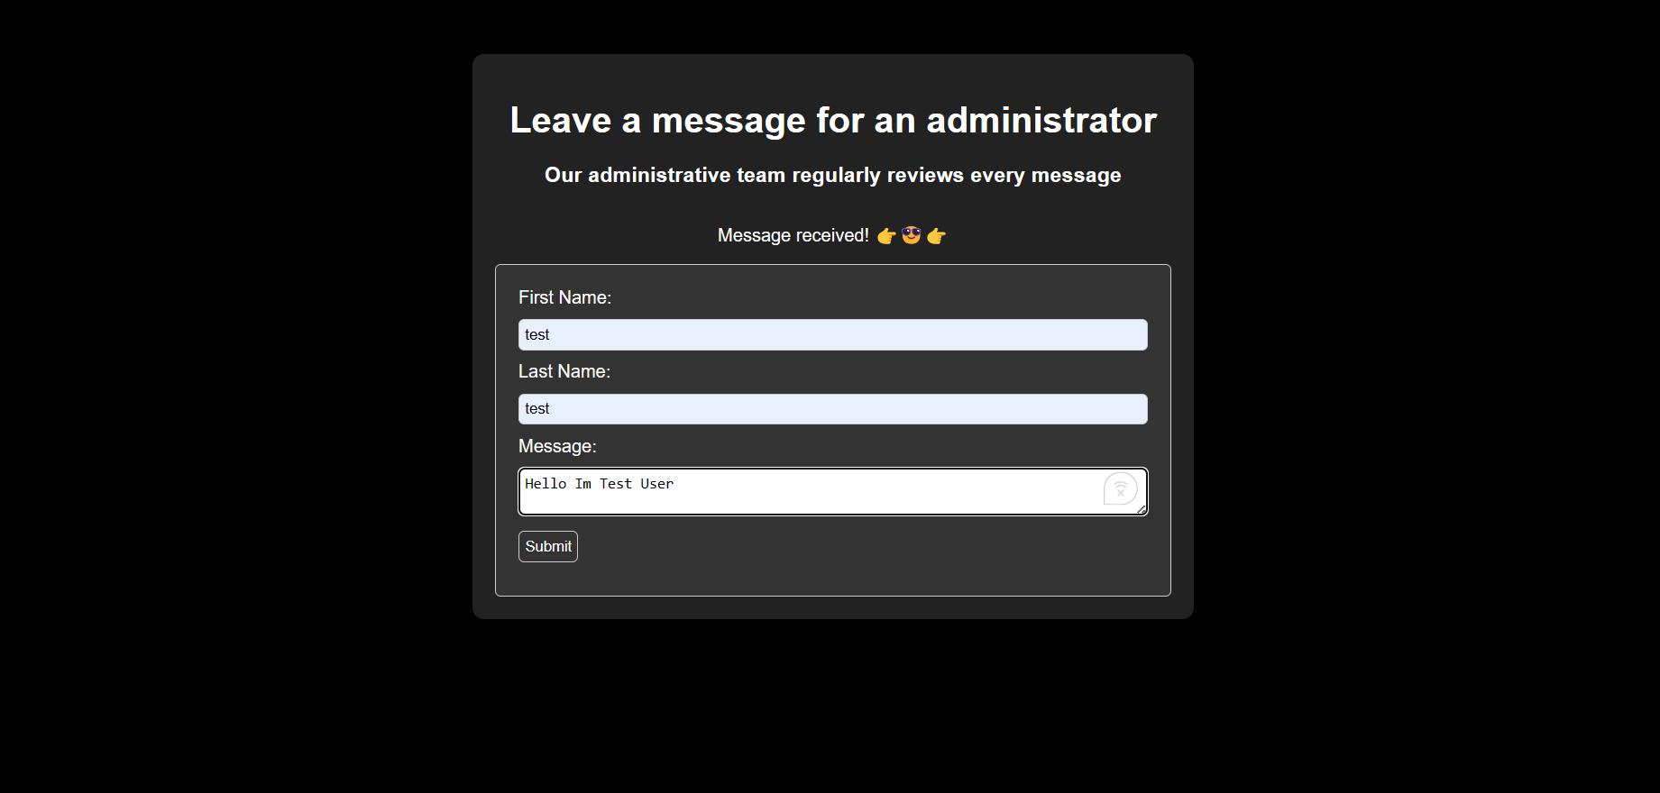

Here we send a message to the admin then it say message received

We are using this payload

| "><svg/onload=alert('XSS')> But first URL encode it  %22%3E%3Csng%2fonload%3Dalert%28%27XSS%29%29%3E |
| --- |

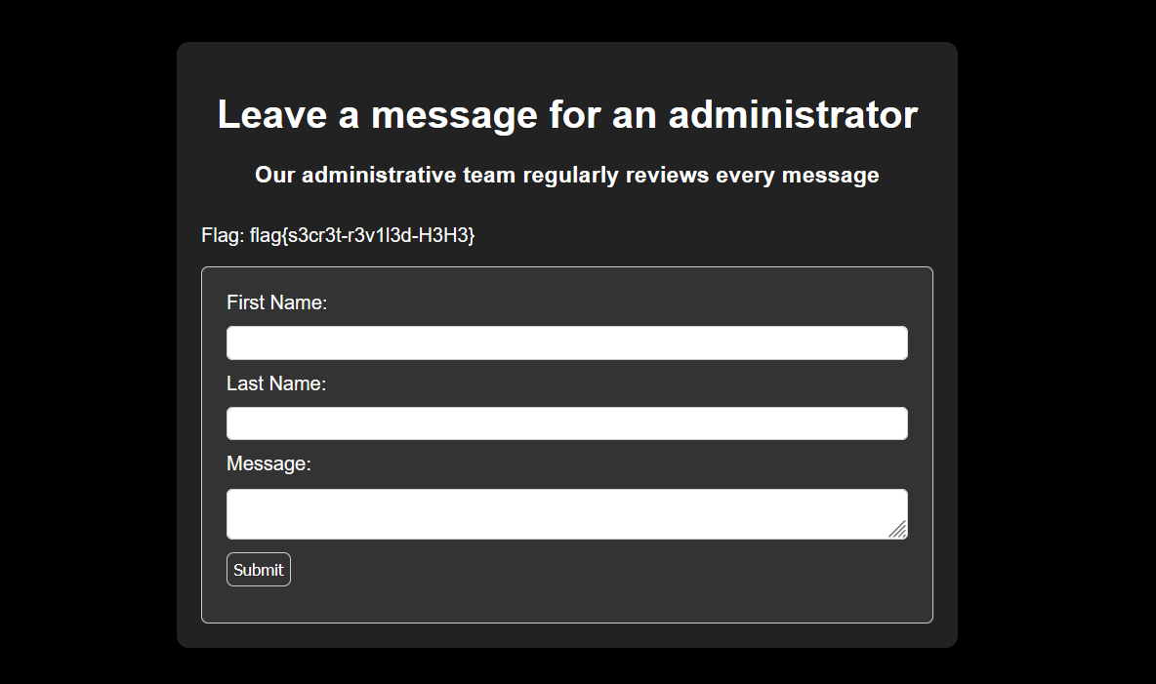

This page is intentionally left blank